Image | 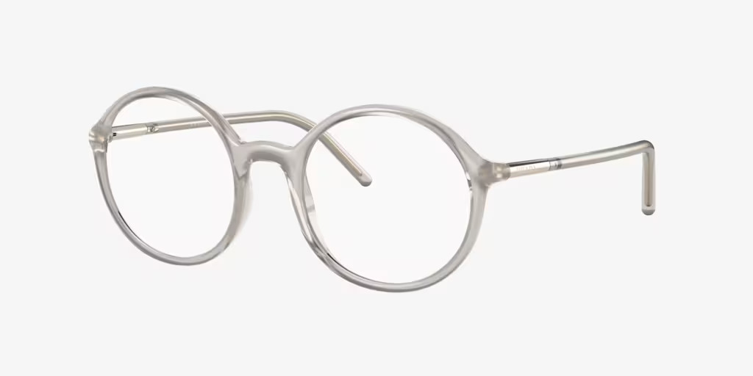
Brand | PERSOL
Model Name
Price
PRODUCT DETAILS

